# Beef Nutrition!

Fill in the blanks during your class discussion about beef nutrition. Then, keep this worksheet to reference later!

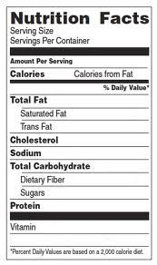

High amounts of zinc, iron, and protein (ZIP!)

Yes!

Zinc, iron

26 grams

12 grams

217

3 ounces

**What food group is beef in?**

dairy or protein (circle one)

**Can beef be a part of a healthy diet?**

**What makes beef healthy or unhealthy?**

**Do you like to eat beef?**

s:

Other notes to remember:

**My beef product: My group members:**